Guided Tour - Authoring in Clilstore

Elementary steps
This is a step by step guide demonstrating how to make an online unit with video and text where all the words are linked to a variety of online dictionaries. The unit demonstrated is found at http://multidict.net/cs/780

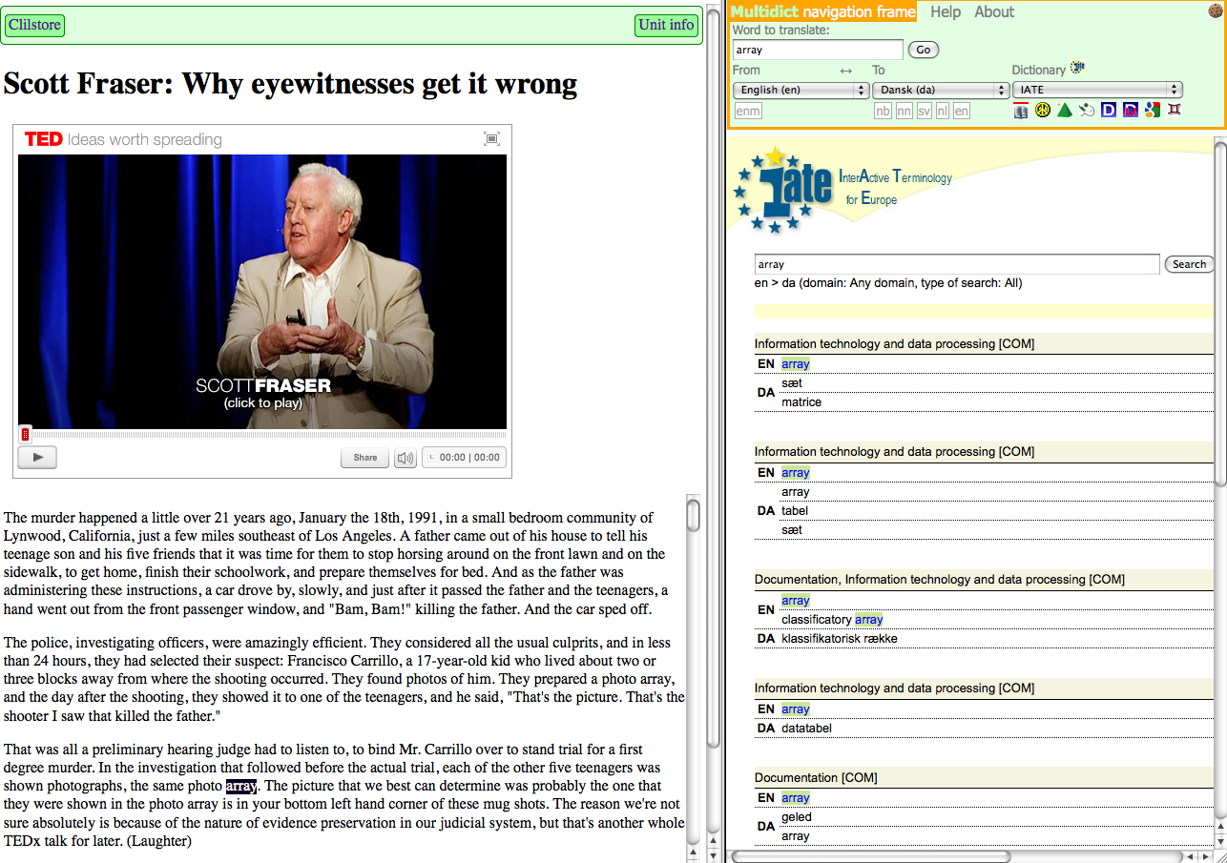
  - Figure 1. Unit 780 after a click on the word “array”.

Go to http://multidict.net/clilstore and click “register”. It is now time to select a user name, password and provide your first name, family name, and e-mail address.

  - Figure 2: The Clilstore entry page.

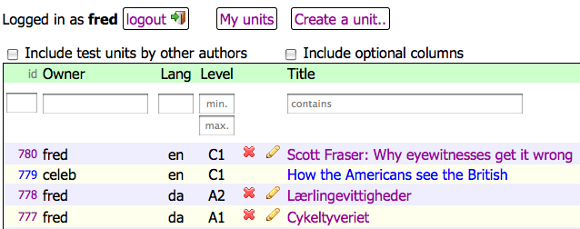
  - Figure 3: The Clilstore home page.

Having logged in, one can create new units or edit existing units (it is also possible to delete X one’s own existing units). Now it’s time to click “Create a unit”.

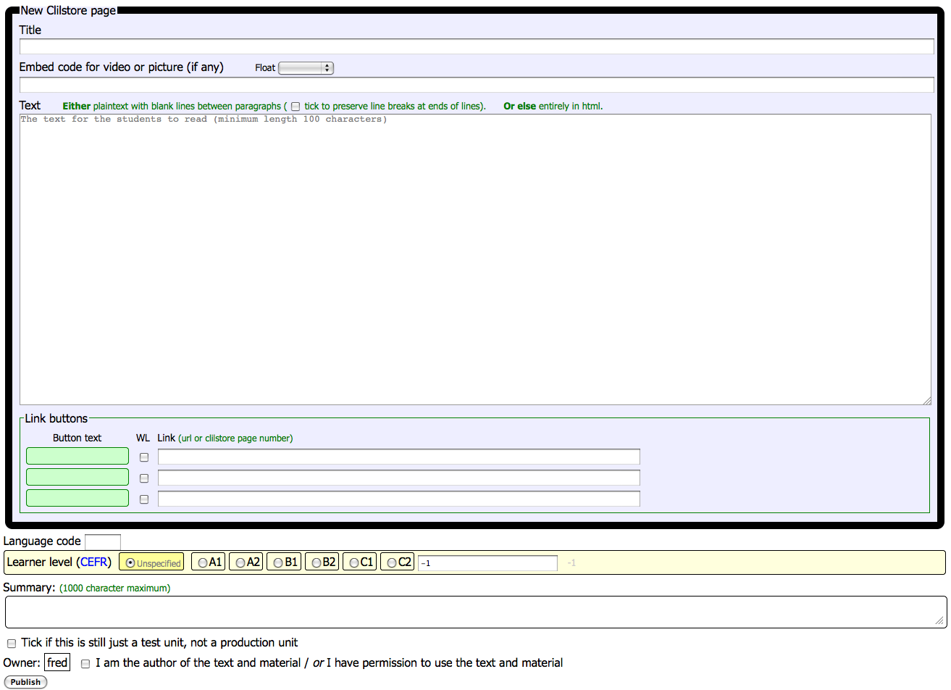
  - Figure 4: Creation of a unit in Clilstore with video and text.

The “Create a unit” page has a number of fields and options. This description will go through them from top to bottom:

- Title: Write a suitable heading for the new unit.
- Embed Code > “Float”: Choose where the text will be positioned in relation to the video/audio player frame or photo.
- Embed Code: In order to embed a video/audio or photo from Youtube.com, TED.COM, Vimeo.com, Flickr.com, etc. one has to look for the option “Share and Embed” and then copy and paste the full embed code (which consists of HTML code) into the field “Embed code for video or picture”. See example from TED.COM below:

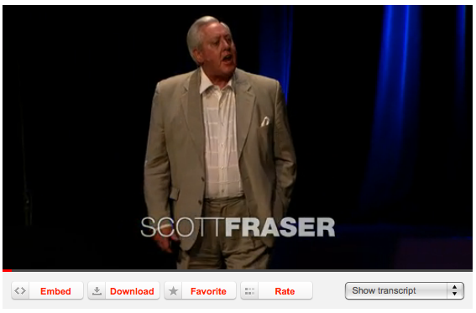
  - Figure 5: Video from TED.COM with “Embed” button and “Show transcript”.

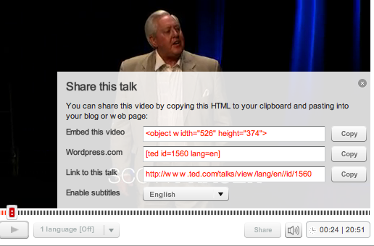
  - Figure 6: Copy the code after clicking the “Embed” button

- Text: Please note that there should be a blank line between each paragraph to ensure a nice layout of the final result.
*Note the tick box in the middle of the green coloured instructions -if the text is a song text, then a tick here will ensure that the line breaks are kept so the stanzas appear properly.
- Text: There are several websites that offer both video and transcripts, e.g. http://www.languages.dk/digital where there are videos in several languages. In this example we’ll use a video from TED.COM (http://www.ted.com/talks/scott_fraser_the_problem_with_eyewitness_testimony.html), just click on the button “Show transcript”, select “English”, then copy the full text, and paste it into Clilstore.
- Link buttons: Here it’s possible to create buttons that link to other webpages and exercises. Write a short title in the green field “Button text” and write the full web address in the “Link” field (it is highly recommended to copy and paste in addresses so there is no misspelling). Please note that there is a check box listed “WL”, if this box is ticked then the page linked to will be processed so that all the words are linked to online dictionaries (Note that some web pages have errors so they do not work with the WL feature).

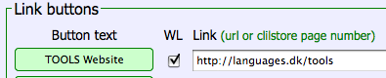
  - Figure 7: Making a button with a link to the TOOLS website with all words linked to online dictionaries

- Language Code: Remember to use the international abbreviation for the language of the text, e.g. EN for English. This is needed for Clilstore in order to retrieve the right dictionaries (if you are unsure of your language code you can check it easily by going directly to http://multidict.net/multidict/ and selecting the drop down menu in the ’from’ field)
- Learner level: Estimate the level needed by a learner in order to benefit from the unit. These levels are based on the Common European Framework of Reference for Languages (http://www.coe.int/t/dg4/linguistic/cadre_en.asp)
- Summary: Write a short appetizer describing the content. The text will be searchable from search engines such as Google.
- Tick if this is still just a test unit: Please only tick this box if the unit is unfinished or is only an experiment, and in that case please remember to delete it later.
- Owner: Tick this box if you have the right/permission to use the texts and video etc.
- Publish: Click and share with colleagues around the world

That’s it: Your unit has been given a number e.g. 780. This means that the web address to your unit is http://multidict.net/cs/780 (just replace 780 with the number of your unit).

Advanced Steps
After a unit has been created it is possible to edit the unit and e.g. add links to other web pages or complimentary units by using “Link Buttons” and pasting in the link.
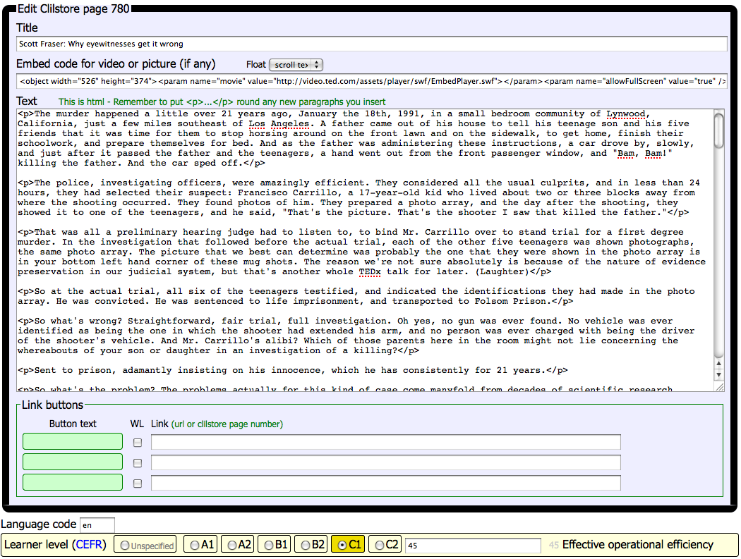
  - Figure 8: Sample Clilstore exercise editing page.

BUT please note that the text in the “Text” window is now formatted like HTML. Each paragraph starts with <p> and ends with </p>. If you want to edit/change words then just avoid deleting e.g. the <p>. Should you wish to insert a new paragraph in the text then remember it has to start with <p> and end with </p>.

If you wish to insert a photo from Flickr.com between two paragraphs then from a photo in Flickr, click Share and “Grab the HTML/BBCode” (which is the way Flickr offers its embed code):

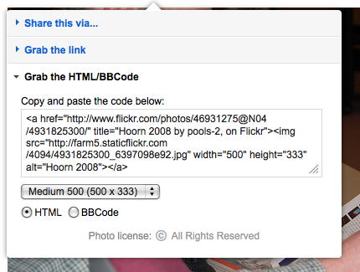
Figure 9: Sample embed code from Flickr.

The copied code (and hence the photo) can now be pasted into the “Text” field as long as it is placed between two paragraph symbols “</p> and <p>”

The same procedure can be used for embedding another video or an audio file between text paragraphs.

If you are not satisfied with your text and want to redo the work, then it is probably easiest to start from a new unit, unless of course you want to put in the <p> and </p> codes around each paragraph.

Important notice

This guide matches the Clilstore as it looked in September 2012. The guide will be regularly updated and in 2013 (or earlier) supplemented by demonstration videos.

If you experience any type of errors in Clilstore or have suggestions for improvements then please mail: Caoimhin O Donnaile caoimhin@smo.uhi.ac.uk

Useful links

Tools outcomes
- Clilstore: http://multidict.net/clilstore
- Multidict: http://multidict.net/multidict
- Wordlink: http://multidict.net/wordlink
- Tools website: http://languages.dk/tools/index.htm
- Tools Facebook: http://www.facebook.com/tools4clil
- Tools Blog: http://tools4clil.wordpress.com/
- Tools Twitter: https://twitter.com/tools4clil

Ressources
- TED (Technology, Entertainment, Design) +900 videos, many with transcript: http://www.ted.com/
- Vimeo, site with videos resources http://vimeo.com/
- Youtube, site with video resources: http://www.youtube.com/
- Ipadio, site with audio resources: http://ipadio.com/
- eCorner, site with video resources: http://ecorner.stanford.edu/popularVideos.html
- videojug, site with video resources: http://www.videojug.com/

The TOOLS project has been funded with support from the European Commission. This publication reflects the views only of the author, and the Commission cannot be held responsible for any use which may be made of the information contained therein.

